http://www.tanjoh-ji.jp/e_sosidou.html

Birthplace of Holy Priest Nichiren
The Holy Priest Nichiren was born in a fishery family by the beach of Kominato Village in Chiba Prefecture on February 16, 1222. It is said that three lovely miracles happened on his birthday : a Spring of pure water suddenly gushed forth in a corner of the garden ; many lotus blossomed in full on the cold beach ; and lots of sea-breams gathered up near the surface of the sea. He was named ZENNICHIMARO.
At the age of thirty-one Holy Priest Nichiren began to chant the odaimoku, facing the rising sun, at SEICHO-JI on April 28,1253. After many years of severe study in Buddhism, he was convinced that the Lotus Sutra was what Sakyamuni Buddha had preached in order to save all living beings.
Despite various persecutions, he devoted himself to the propagation of the Lotus Sutra. He met with four great persecutions and countless minor abuses. Finally he was arrested and brought to Tatsunokuchi Beach to be executed unofficially. Having failed to kill him at Tatsunokuchi, the Kamakura Shounate exiled him to Sado Island for about three years.
On three occasions he remonstrated in vain to the military government at Kamakura. Though he was pardoned and came back to Kamakura, he left there without paying attention to an attractive offer by the government.
The Holy Priest Nichiren has been worshiped by his followers as a reincarnation of the Bodhisattva Visistacaritra described in the Lotus Sutra. The sutra states that Sakyamuni Buddha had ordered this Bodhisattva to propagate the sutra in the depraved world where we live.
He had come to realize himself to be a real practitioner of the Lotus Sutra when he was about to be executed and exiled to Sado Island. Anyone may understand this by reading Kaimoku-Sho, one of his major writings.
He entered Mt. Minobu, where he kept on upholding the teaching of the Buddha, educating many disciples and lay devotees, and communicating with those who lived afar.
When he was sixty years old, he left Minobu to have treatment at a hot spring resort for a sickness from which he had been suffering for the past several years.
At Ikegami, Tokyo, on the morning of the 13th of October, 1282, he passed away. His relics were enshrined at the KUON-JI, Minobu, as he willed in one of his letters.
As for the founding of the TANJOH-JI, Holy Priest Nichiren visited his critically sick mother in 1264 and prayed for her recovery. He succeeded in animating her, and she was able to live four more years. In gratitude she had a small shrine built.
In 1276, a temple was founded and reported to the Holy Priest Nichiren by two of his direct disciples, Nike and Niho, who later became the Second and the Third Chief Abbots of the temple. The Holy Priest Nichiren named it Kokozan Nichiren TANJOH-JI.
The temple was originally located at the site of the Holy Priest Nichiren's birthplace but was moved to the present location after it was destroyed twice by earthquakes and tidal waves in 1498 and 1703.
The Twenty-sixth Abbot Daichuin Nichiko had a typical set of splendid buildings reconstructed with financial support extended by Tokugawa Mitsukuni, feudal lord of the Mito Clan, and changed the temple's name to Kominatosan TANJOH-JI.
In 1758, however, all the buildings were burnt down except the Gate of Two Guardian Kings (Nioh-Mon).
The Forty-ninth Abbot Ichijoin Nissen had the present Soshi-Doh (Founder's Hall) built in 1842 after ten years of hard work. It was so huge and splendid that everyone could not help admiring this building. The temple received special financial assistance from the Satomis and the Masakis.
When the Crown Prince of Emperor Meiji was in poor health, TANJOH-JI was asked by concerned members of the imperial family to say prayers for his health. He recovered his health to become Emperor Taisho (reigned 1912-1926).
A shrine for the Prince Arisugawa family was also built in the temple precincts.
The Eighty-second Chief Abbot Nissen Katagiri organized the "Gojumannin-ko" (Five Hundred Thousand Devotee Association) to finance renovation and new construction projects beginning in 1985. With enthusiastic support of many devotees, these projects were successfully completed and dedicated in a ceremony in May, 1992, officiated by Nichiyu Iwama, Chief Abbot of Minobusan KUON-JI, General Head Temple of the Nichiren Sect, who is concurrently Archbishop of the same sect in Japan.
In additon, Chief Abbot Katagiri is at present appealing for nation-wide support in order to put the finishing touches to the works of the "Gojumannin-ko." He has asked Masters Kyo Ishikawa to work on the mural painting of the Jataka Tales depicting "The Buddha's Previous Lives" and Ko-Hasegawa on the statues of the "Ten Great Disciples of Buddha." Upon completion, these works of art, in harmony with the religious atmosphere, it is believed, will greatly impress visitors.
The TANJOH-JI, one of the Grand Head Temples of Nichiren Sect, has been visited with reverence by devotees from all over Japan through all seasons.
Quite a number of people from the rest of the world also pay homage to the temple, enjoying the beautiful scenery, as well as the wonderful atmosphere surrounding it.

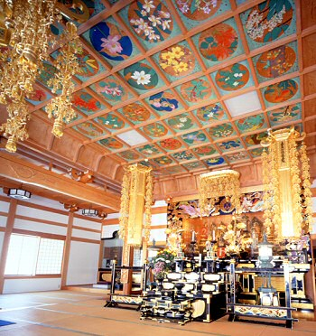
Inside of HON-DOH

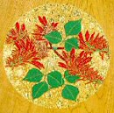
Painting, by Master Kyo Ishikawa
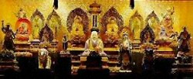
A Set of Statues expressing Ten Realms Mandala

HON-DOH (Main Hall)
Completed in Oct. 1991, it is 250 square meters. Enshrined on the alter are wooden statues (carved by Sakyo Hogen Koku, a Buddhist sculptor in Kyoto, in 1684) arranged in order so as to show the mandala honzon (object of worship written in Chinese characters), manifesting the doctrine of mutual possession of the Ten Realms.
They were donated by Tokugawa Mitsukuni powerful feudal lord of Mito Province and a close relative of Tokugawa Shogun.
This set includes a statue of Hariti or Kishimojin, too. The deity, originally of Indian religion, is usually engraved in ugly and horrible styles. The one in this temple, however, is carved as a mother who holds a baby on her breast with her left hand, holding up a twig of pomegranate tree in her right hand. So, it is called the "Baby Protecting Hariti."
At present many temples of Nichiren Shu enshrine this deity, regardless of its looks because it is mentioned in the Lotus Sutra and to help them propagate the Buddha's teaching.
There is a story that one when the Buddha stayed at Rajagrha, some mothers came to ask Him to save them from the horror of Hariti. She had already kidnapped and eaten 999 babies from many families. Mothers in the city were too scared to sleep at all. The Buddha took measures to help them.

One day Hariti found one of her babies lost. The Buddha had hidden it. She missed it so much that she finally became insane, not knowing how to find her lost baby. She asked lots of people if they had seen her missing baby, but nobody knew of its whereabouts. Everything she did was in vain.
In the end she went to see the Buddha, who told her, with all his heart, how sad and desperate those mothers whose babies were missing were. She had many children, and she missed the lost one so much that she had to run around looking for it all over the city day and night.
After talking with the Buddha, she became sane and repented of what she had done up until that time. Under the shade of a big tree she swore to Buddha that she would protect babies and those who believe in the Lotus Sutra that the Buddha preached.
Thus Hariti was saved by the Buddha's hearty guidance and could become a god.
On the ceiling of the sanctum eighty-five pictures depicting Buddhist plants with flowers are painted by Master Kyo Ishikawa.
Right on the center of the altar of the left outer chamber is enshrined a wooden statue of Benzaiten or Sarasvati carved by Master Fusazo Nishimura. This deity for people's happiness was originated in ancient India, and was later adopted in Buddhism.
Enshrined on the left corner of the altar are two images of Kannon and Myoken Bodhisattvas, an amulet which contains the "Jigage" verse (essence of the Lotus Sutra) written in gold ink on dark navy blue paper, and two sets of small images of Holy Priest Nichiren and his parents.
They all had been kept in the private room of Empress Dowager Shoken. Also on the altar are two bottles filled with pebbles, on each of which her Majesty wrote a Chinese character from the "Jigage" verse.

Also placed on the altar are three tables for Emperor Meiji, Empress
Dowager Shoken, and Emperor Taisho; two tables for Prince Taruhito and Prince Takehito of the Arisugawa Family; and three tables for emperors including the Ninety-sixth Emperor Godaigo; one tablet for the close retainers of the Imperial Court.
Enshrined on the altar of the right outer chamber are the statues of the Second and Third Chief Abbots Nike and Niho, together with mortuary tables of the succeeding chief abots of this temple.
The rear room is used for enshrining the mortuary tables of lay followers registered for perpetuity.

SOSHI-DOH
(Hall housing wooden statue of Holy Priest Nichiren)
The construction of this structure was started in 1832; it took ten years to build. It is made entirely of zelkova wood. The 48 zelkova columns had originally been earmarked to be used in building Edo Castle (Castle of the Tokugawa Shogunate, now current Imperial Place in Tokyo), but while in transit, the ship carrying the lumber foundered, and the lumber was then purchased by the TANJOH-JI. When you enter the building, straight ahead of you in the inner sacred shrine you will see a statue of the Holy Priest Nichiren. This statue of the Holy Priest Nichiren was made in 1363

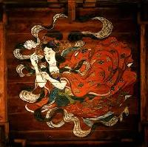 A heavenly maiden

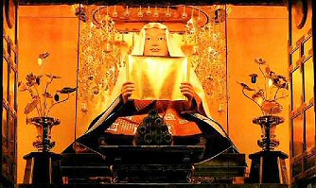Holy Priest Nichiren

HONSHI-DEN HOTOH
(Inner sanctum of treasure tower where the statue
of Sakyamuni Buddha is enshrined)

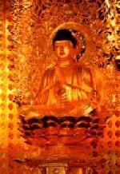
Sakyamuni Buddha

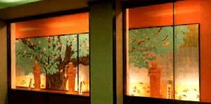
Ten Great Disciples of the Buddha
by Master Ko Hasegawa

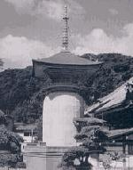
The statue of Sakyamuni Buddha is three meters(10 feet) high, and is gilded with gold leaf over a Japanese lacquer finish. In the walls, 500,000 flower petals in 2,019 cases are kept in permanent storage. The scattered flower petals are lotus blossom petals, and they are used as decorations or scattered about to extol the virtues of Sakyamuni Buddha.

RINZOH
(Revolving shelves for storing of Buddhist scriptures or sutras; located underground below tower)
The Buddhist scriptures or sutras copied by believers are kept in red Japanese lacquer finished boxes, and stored on shelves that are divided into 84 sections. The entire shelf assembly makes one complete revolution every 30 minutes. Aluminium plates on which the scriptures have been micro-filmed are in permanent storage.

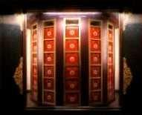

HOHMOTSU-KAN
(Hall in which memorablia of the Holy Priest Nichiren and the Nichiren Sect are on display )

On display are items that were presented by members of the Imperial Family or feudal lords, or writings closely related with TANJOH-JI that were penned by priests. Here there are also three wooden statues. These wooden statues were caught in the nets of fishermen at the old site of TANJOH-JI.

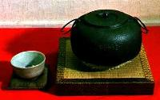
HOHKA-DOH CHAGAMA
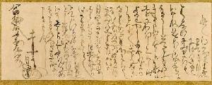
Priest Nichiren's letter

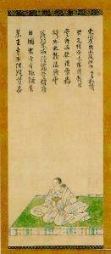

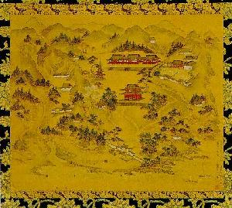

KYAKU-DEN
(Structure where Members of the Imperial Family are received)
This is a structure built in 1939 entirely of cypress wood to receve members of the Imperial Family of Japan.

JOHDAN-NO-MA
(Chamber with floor elevatedabove rest of structure's floor)
In the large vault in this chamber is kept a painting of Emperor Meiji(who reigned as Emperor of Japan from 1868 to 1912) painted when His Imperial Majesty was 16 years old.
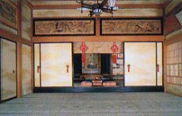

BOTAN-SAKURA-NO-MA
(Peony and Cherry Blossom Chambers)
These are chambers with staggered shelves (two shelves installed at staggered heights). They are called the Peony and Cherry Blossom Chambers because of the pictures of peonies and cherry blossoms that are depicted on the sliding doors dividing the chambers

NI-OH MON
(Gate with figures of two Buddhist guardian deities on guard)
This gate was built in 1705. It is the only structure that remains after a devastating fire that occurred about 240 years ago, and is thus the oldest structure at the temple

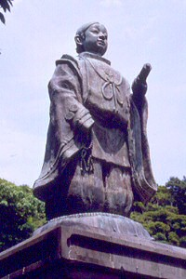
Holy Priest Nichiren

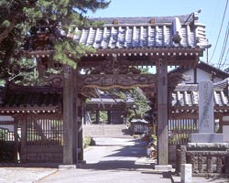
ＳＯＨ－ＭＯＮ（Outer Gate)
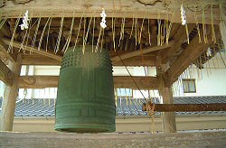
SYOROH-DOH
RYUOH-DOH
(Shrine for Eight Great Dragon Kings)
Founded in 1861, the Eight Great Dragon Kings described in the Lotus Sutra are enshrined for the safety of navigation

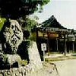

OHTA-DOH(Ohta Shrine)
Founded in memory of Ohta Shinrokuro during the Tensho Era (1573-91), this Inari shrine was rebuilt in 1978.
Shinrokuro was a grandson of Ohta Dohkan, initial founder of the Edo Castle (present Imperial palace), which was later taken over by the Tokugawa Shogunate. Shinrokuro lived at TANJOH-JI in seclusion after retirement and was buried with his wife at this temple.
This Inari deity, originally the guardian of the Ohta family, has been worshiped as the protector of fishermen and seamen

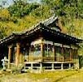

TANJOH-DOH
(A shrine dedicated to the birth of Holy Priest Nichiren)
Rebuilt in April, 1983. Three statues : Holy Priest Nichiren and his parents, carved out of one piece of wood, are enshrined.
On the days of annual birthday celebration this statue of the young founder is carried and enshrined in the center of the Soshi-doh.

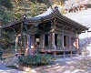

KINEN-HI
Monument commemorating the successful completion of the renovation and new construction work of TANJOH-JI by the "GOJUMAN-NIN-KO" (Five hundred thousand devotee association) in May, 1992.

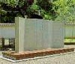

HATSU-MOHDE
(New Year prayer pilgrimages)
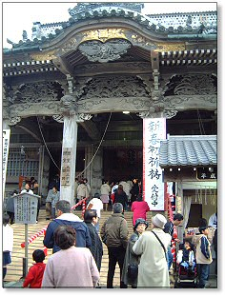
In Japan, the tradition is for people to visit temples or shrines to offer prayers for good health and prosperity for the year. In this region where it is so warm that rape-seed blossoms bloom even during the winter, there is more vitality than would be seen at other similar places of worship during the winter.

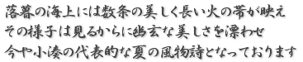

TOHRO-NAGASHI
A traditional event where Japanese lanterns are cast afloat on the sea)
UMI-SEGAKI-E (TOHRO-NAGASHI)
("Hungry-Spirits-Feeding" on the sea festival mass service)
UMI-SEGAKI-E (TOHRO-NAGASHI)was held on August 10
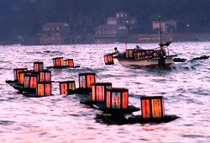

In this event, several beautiful long stripes of fire are seen on the sea after nightfall. This beautiful scenery builds up a mood of quiet beauty, and it is part of the natural poetic charm of summer in Kominato.
Before the TOHRO-NAGASHI, a memorial service is performed for each MIZU-TOHBA (water stupa) and TOHRO (Japanese lantern) on which words of prayers are written so that the spirits of the dead would response in peace. After the memorial service, the lanterns are cast afloat onto the sea of TAI-NO-URA (Bay of Sea Bream)
.
A large number of lanterns, which are loaded on four excursion boats of TAI-NO URA, are cast afloat one by one onto the sea after the candle inside each lantern has been lit.
During the TOHRO-NAGASHI, the skies are filled with colorful firework displays, which are reflected on the surface of the bay adding to the extremely beautiful scene of the floating lanterns. The scenery is so beautiful that some of the visitors cannot stop weeping and repeating Nichiren prayers with clasped hands.
THE HISTORY
280 years ago, on November 22, the 16th year of Genroku, over four hundred Kominato villagers lost their lives in one night because of a large Tsunami caused by a great earthquake which hit the entire area of Boso (present Chiba prefecture). As a memorial of this disaster, the head priest of the Tanjoh-ji Temple, Daichu-In-Nikkoh-Shohnin (26th) made a large image of Buddha and all secular and posthumous Buddhist names of the victims were written down and placed within. From then till the outbreak of World War II, a Memorial Service was held every month on the 22nd, the anniversary of their death. After the war, this memorial service was expanded to include war victims and was transformed into the UMI-SEGAKI-RYUTOH-E (Memorial service of TOHRO-NAGASHI) of today at TAI-NO-URA. The festival became more and more prosperous every year. Today, more visitors, not only from the Tokyo-Yokohama area but also from the Kansai (Western Japan) area, come to visit and spend nights in Kominato to participate in the TOHRO-NAGASHI memorial service for ancestors, victims of the sea and land disasters, and spirits of the dead whether they are personally related or not..

OESHIKI
(Memorial Day Service for Our Founder)
This is a mass service in which memories of the late Holy Priest Nichiren are recalled, and thanks are expressed for the Holy Priest having spread the teachings of the Sutra of the Lotus Flower of the Wonderful Dharma (Lotus Sutra). This Sutra is one of the Sutras that Sakyamuni Buddha, or the Sage of the Sakya Clan, preached.

SHICHI-GO-SAN MOHDE
(7-5-3 Festival pilgrimage)
This is an event in which children of seven, five and three years of age visit the Temple accompanied by their parents and family members, to express thanks for their having attained their respective ages, and to pray that they will enjoy good health in the future. The precincts of the temple are thronged with many children dressed up in colorful attire.

Tanjo-ji Temple is the place where Nichiren Shonin was born.
This is a solemn, sacred place located in Kominato, in Southern Chiba, surrounded by the Pacific Ocean. Nichiren Shonin was born in 1222. His father was Nukina Jiro Shigetada, and his mother's name was UmegikuIn celebration of Shonin's birth, lotus flowers bloomed on the seashore, red snapper gathered, and spring water gushed out into the yard of the house.
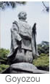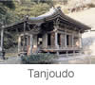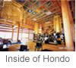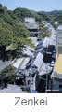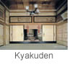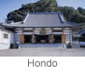

These places are now preserved as Renge-ga-fuchi,
Tae-no-ura, and Tanjo-ido. Shonin's mother dreamedthat the sun entered her bodywhen she became pregnant, so they named their son Zen-nichi-maro, meaning "Boy with the Good Sun".
After Nichiren Shonin proclaimed his new path of Buddhism, he continued his mission in Kamakura.But in January of 1264 he learned that his mother was ill and returned to his hometown. He inscribed a mandala and prayed for his mother's recovery. Because of his great merits, his mother's life was extended for another four years.
In October of 1276, Nichike, one of Nichiren Shonin's second senior disciples, built a temple on the grounds where Shonin's parents' home stood. The patron of this temple was named Sakuma-Hyogo-no-kami Shigetada.
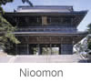 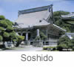
The temple was originallyat the place where Tae-no-ura iscurrently located. But in August of 1498 the temple was destroyed by a tsunami. The temple was rebuilt, but the second temple was also destroyed by a tsunami,in November of 1703. During the Hoei Period (1704-1710), Nichiko restored the temple at its present location.
At that time, a local lord donated the property,
Temple Structures
- Hondo (Main Hall)
- Honshi-den Hoto (Treasure Stupa)
- Treasury
- Ota-do (Hall of Ota)
- Tanjo-do (Hall of Nichiren's Birth)
- Kyaku-den (Social Hall)
- So-mon (Great Gate)
- Tanjo-sui no ido (Mill of Birth Water)
Temple Treasures
- Seven mandalas inscribed by Nichiren Shonin
- Mandalas inscribed by former resident minister
- Belongings of Lord Mitsukuni Mito
- Belongings of Lord Kiyomasa Kato
- Drawings by Taosali Soma on the ceiling of Soshido
Temple's Annual Events
January 1 New Years Prayer
February 16 Celebration of Nichiren Shonin's birthday
April 15 Senbu-e (Reading of the Lotus Sutra a thousand times)
August 10 Segaki
November. 12 Oeshiki (Nichiren Shonin's memorial service)

