Myohōnji Temple - 妙本寺 (built 13th century onward)
Myohōnji temple is erected at the site of a battle that occurred here in the early 13th century between two factions competing for the Shogunate. The founder of the temple, Yoshimoto, established the temple for the respite of the souls of his father and family members who had been killed in the battle. This was done at the advice of the priest Nichiren, whom Yoshimoto greatly admired.
An excellent description of the temple may be found at the following external website: http://www.asahi-net.or.jp/~QM9T-KNDU/myohon.htm

Myohonji is one of several temples of the Nichiren sect of Japanese Buddhism along the southeastern hills of Kamakura. The temple was founded by Hiki Yoshimoto in 1260, and features a statue of Nichiren to the left of the main hall.
The temple is connected via the Gionyama hiking trail with some other nearby temples and a shrine. It leads through the wooded hills of Kamakura, and should be explored only with good walking shoes and during dry weather, because there are a few steep and rough passages.

Historical Overview
The Temple stands peacefully at the foot of a hill as if it has been nesting there for centuries. Way back in the 13th century, however, there was a great tragedy right on this site triggered by the power struggle among samurai factions. After the death of Yoritomo Minamoto (1147-1199), the founder of the Kamakura Shogunate, the Shogun's post was succeeded by Yoriie Minamoto (1182-1204), Yoritomo's first son. He was only 16 years old, too young to be at the helm of the Shogunate, and the real power went into the hands of Masako Hojo, his mother, and Tokimasa Hojo (1138-1215), his grandfather.

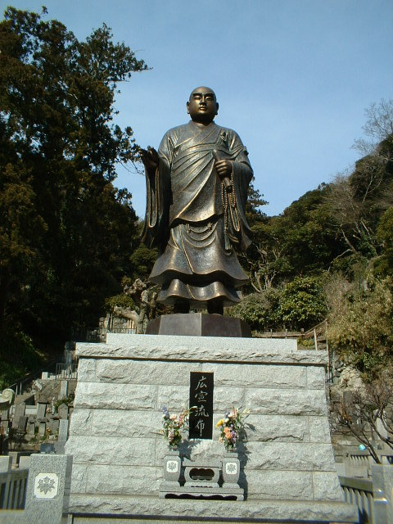
Yoriie was not happy at all with the way his mother and grandfather treated him. He addicted himself to girls-hunting and had several mistresses in his teenage. In 1203, Yoriie fell critically ill for no apparent reason and death seemed to be imminent. Just in case, Masako and Tokimasa planned to split the Shogunate territorial right into two; one for Yoriie's son Ichiman and the other for Yoriie's younger brother Sanetomo (1192-1219). Yoriie had married Wakasa, daughter of Yoshikazu Hiki (?-1203), who was the head of another samurai family.
Yoriie's first son Ichiman was only 6 years old when Yoriie fell seriously ill. Should Yoriie die, Ichiman was supposed to succeed to the Shogun's position since the first son of Shogun had been customarily entitled to do so. If Ichiman assume the seat of the Shogun, Yoshikazu Hiki and his family would be enormously powerful as they become the Shogun's maternal family. That was what the Hojos had feared.
The Hikis had had close connection with Yoritomo from his early days. As a matter of fact, Yoshikazu's mother-in-law helped young Yoritomo materially while he was in exile to the Izu Peninsula, and Yoshikazu's wife raised Yoriie as a wet nurse. Naturally, Yoriie liked the Hikis more than the Hojos.
Hearing Masako and Tokimasa's plan designed for the dual ownership system, Yoshikazu got upset because he believed the first son of the Shogun, Ichiman in this case, should inherit all of Yoriie's right and property according to the rule of the day. At the bed side of sick Yoriie, Yoshikazu told him that Masako and Tokimasa were trying to oust Yoriie. Even further infuriated, Yoriie told Yoshikazu to immediately ruin the Hojo family. At the other side of the bed room, Masako eavesdropped the conversation and the Hojos conspired to take the initiative.
Soon afterwards, Tokimasa invited Yoshikazu to attend a religious ceremony to be held at Tokimasa's residence for a new statue of Yakushi Nyorai, or Bhaisajyaguru in Skt. he had prepared to invoke Yoriie's recovery from the ailment. Yoshikazu accepted the invitation despite his retainers' advise otherwise, in the hope that conspiracy would be least likely to be involved in the religious event.
Yoshikazu was wrong. He went to Tokimasa's residence bringing only several aides with him. Upon his arrival, Tokimasa's men assassinated him in a surprise attack. The bereaved family of Yoshikazu and samurai of the Hiki clan gathered right away at Yoshikazu's residence, where today's Temple stands, to prepare an unavoidable revenge. Tokimasa and Masako had expected the ensuing scenario in advance and had made an ally of other powerful factions. The Hojos and its ally, taking the first move, attacked Hiki's residence. A bitter fighting continued for several hours taking heavy tolls, and the Hikis were defeated in the end. It was in 1203. Some 100 people were slaughtered in this battle including Yoriie's son Ichiman. Witnessing her family members were killed, Wakasa committed suicide at the site. The Hikis were thus wiped out almost totally.
After the battle, bed-ridden Yoriie was forced to step down as the Shogun and was deported to the Izu Peninsula, where he died (some say he was killed) a year later in 1204. The Shogun's position was succeeded by Sanetomo Minamoto, second son of Yoritomo and Yoriie's younger brother. He was only 12 years old.
The Hikis were survived by an infant: Yoshikazu' last son Yoshimoto (1201?-1286), the founder of the Temple. He was sent to Kyoto and served Emperor Juntoku (1197-1242). When the Emperor was exiled to Sado Island off Niigata Prefecture in 1221 as a result of the unsuccessful attempt to overthrow the Kamakura Shogunate, Yoshimoto followed the Emperor to the island and stayed there for 21 years. With the death of the Emperor, Yoshimoto came back to Kamakura, where he encountered with Priest Nichiren (1222-1282), the founder of the Nichiren sect. Priest Nichiren was making street preachings at busy corners of Kamakura. Yoshimoto was deeply moved by the Priest's sermon and volunteered to become a disciple, though he was 21 years senior to the Priest. Yoshimoto even helped the Priest draft the famous treatise entitled "Pacifying the State by Establishing Orthodoxy" (See Ankokuronji). Because of this treatise, the Priest too was later exiled to the same island. However, as soon as the Priest was pardoned and returned to Kamakura, Yoshimoto provided him with his residence as a lecture hall.
Following Priest Nichiren's recommendation, Yoshimoto decided to erect the Temple to console the souls of his father, sister and other family members. Construction of the Temple was completed about 50 years after his family was nearly exterminated. The Temple's official name Chokozan came from his posthumous title and Myohon from his mother's. This is one of the oldest Nichiren sect temples in Kamakura.
(The picture, top, shows a huge bronze statue of Priest Nichiren built in April 2002 to celebrate the 750th anniversary of his propagation. The four Chinese characters read "ko-sen- ru-fu" and denotes to propagate Buddhism based on Lutus Sutra.)
Niten-mon or Two-Deva-King Gate
The inner gate is a huge structure, and in case of Nichiren sect temples, it is often called Niten-mon, meaning a Two-Deva-King gate. The one here encases a pair of statue: Jikokuten, or Dhrtarastra in Skt., and Bishamonten, or Vaisravana in Skt.
Soshido (Founding Priest's) Hall
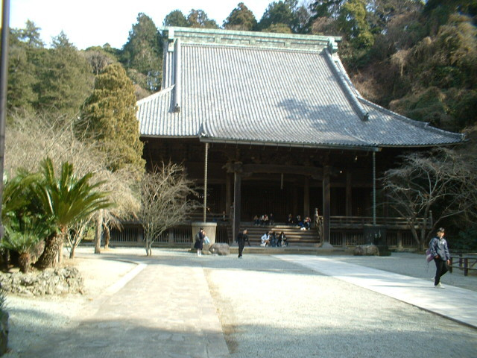

As is usually seen at Nichiren sect temples, the founding priest's hall is grandiose and standing in the center of the temple grounds. As the main object of worship, a statue of Priest Nichiren is enthroned in the center of the altar. This wooden statue was fashioned in the 14th century by Priest Nippo (1259-1341), Nichiren's disciple and an excellent sculptor, while Nichiren was alive, and is among the three that were made out of a single wood-block. The other two are enshrined atKuonji in Minobu, Yamanashi Prefecture (the head temple of all Nichiren sect) and at Ikegami-Honmonji in Ota ward, Tokyo, where Priest Nichiren passed away.
At the left of the Nichiren's statue (to your right) are those of Priest Nichiro and his wife, Yoshikazu Hiki and his wife. Flanking Nichiren's statue on his right are those of Priest Nichirin (1297-1359) (a disciple of Nichiren), Yoshimoto Hiki and their wives. The 9-meter-square hall was rebuilt in the Edo Period (1603-1868).
Reihoden hall
A two-story concrete building near the main hall houses a number of temple treasures related to Priest Nichiren and the founding priest Nichiro. The Temple has quite a few of temple-treasures, such as statues of various deities, ancient documents and Buddhist fittings etc. Unfortunately, the treasures are not on public view.
Ichiman's Sodezuka (sleeve tomb)
On the right-hand side behind the Niten-mon is a small enclosure, roughly 5 meters square, fenced with bamboo, in which stone lanterns and cenotaphs are placed. This is the Ichiman's Sodezuka, or sleeve-tomb. In the debris after the battle here in 1203, a sleeve, apparently part of Ichiman's kimono, was found and was buried here as his memento. The cenotaph was erected in 1904 in commemoration of the 700th anniversary of Ichiman's death. The enclosure is always kept clean and decorated with flowers. Behind the Sodezuka lie several moss-covered tombs and cenotaphs for the major members of the Hiki family. These were placed during the Edo Period (1603-1868).
Main Hall
The main hall stands on the left-hand side between the outer and inner gate, though it is much smaller than the Soshido hall. The main object of worship at this hall is a crowned statue of Shaka Nyorai, or Sakyamuni, reportedly fashioned during the Muromachi Period (1336-1573).

Jakushi Myojin Deity
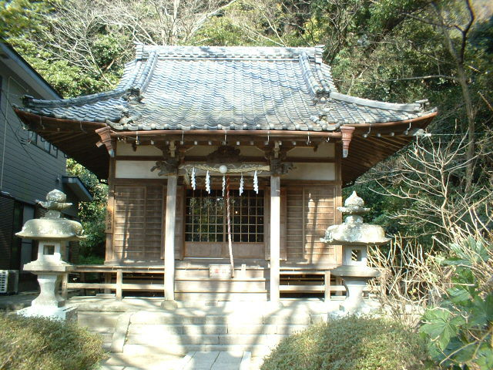
A path to the left running immediately after the first gate leads up to a shrinecalled Jakushi Myojin, which was built for the repose of Wakasa's soul. The moment she knew that her six-year-old boy Ichiman was killed, she is said to have committed suicide throwing herself into a well.
Nearly 60 years after the tragedy of 1203, a series of disasters occurred in Kamakura. In 1256, the Fourth and Fifth Shogun Yoritsune (1218-1256) and Yoritsugu (1239-1256) (Yoritsune's son) died in succession. A couple of great earthquakes hit Kamakura in 1257, and Jufukuji founded by Masako Hojo was destroyed by fire in 1258. People thought they were cursed with evil spirits. The Hojo family underwent similar experiences. Masamura Hojo (1205-1273), the Seventh Hojo Regent (and the fourth son of the Second Regent Yoshitoki), had a daughter who fell seriously ill in 1260. Masamura took every possible measure to make her regain health. One night, he was woken up by a scream of the daughter. He rushed to her bedroom to find her emitting fire from her mouth (sounds like Charlie in Stephen King's Firestarter). She looked like a snake writhing in agony and said that she was an incarnation of Wakasa and wanted to take revenge on the Hojos, who killed her six-year-old son. Masamura promised to the incarnated snake that he would erect a shrine to propitiate Wakasa's soul.
Jakushi Myojin was thus built shortly afterwards to dedicate to her spirit. On the right-hand side of the Shrine is the roofed well. Legend narrates that she transformed into a snake after jumping into the well to kill herself, and yet she had to be in agony in the netherworld. Jakushi literally means to "relieve snake's pain". Annual festival takes place on September 1. The Shrine also serves as a guardian deity of the Temple.

Dai-enbo
A very unique octagonal hall stands on the right-hand side of the Temple approach, which is called Dai-en-bo hall, and used to be a sub-temple of Myohonji. The oldest structure of the entire Temple, it endured the Great Kanto Earthquake of 1923. Today, the hall is used as a kindergarten. Between the first and second gates, the 250-meter-long path is lined with old Japanese cedar, but is cramped with private houses and cars.
Aronia tree In front of the Soshido Hall is a tree named Kaido (aronia or Malus halliana) stands. In early to mid April, pink flowers bloom all over the tree. Other than Kaido flowers, there are Shaga (fringed iris or Iris japonica) in April, Ajisai (Hydrangea or Hydrangea macrophylla) in June, Nozen-kazura (great trumpet flower or Campsis chinensis) in July. In November, Icho (Ginkgo or Ginkgo biloba) will present you beautiful golden leaves.
Notes:
(1) The Temple has long been famous for its Malus halliana flower planted in front of Soshido, which is in full bloom in early April, and draws many photo manias at this time of the year.
(2) In Japan, the Buddha is believed to have come into this world on April 8 and festivals and religious services to celebrate his birth called Gotan-e is observed in many temples on this day. Traditionally, hydrangea tea is served to the visitors. Easter and Passover days sometimes fall on early April, and three major religions in the world honor their religious service almost simultaneously.
(3) In Kamakura, there are scores of Christian churches. Most famous among them is Catholic Yukinoshita Church located on the east side of Dankazuraleading to Tsurugaoka Hachimangu Shrine. Also, Seisen Elementary School near the Hachimangu was established shortly after World War II in commemoration of Spanish Saint Rafaela Maria Porras y Ayllon (1850-1925), or Raphaela of the Sacred Heart of Jesus. The Seisen group also has Middle and High School for girls near Ofuna Kan'non and many others including Seisen Women's College in Tokyo.
(4) Don't be confused with Myohoji (with no n), which is also a Nichiren sect temple located 500 meters south of the Temple.

