Historical Overview
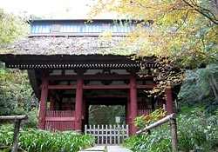

This is the place where Priest Nichiren (1222-1282), the founder of the Nichiren Sect, first settled in 1253 at the age of 31 to begin his missionary work in Kamakura, the nation's capital, coming from his home town in Chiba Prefecture. He made a hermitage here and later built a temple called Honkokuji {hon-kok-gee}, which was, however, relocated to Kyoto in 1354.
Priest Nichiren is said to have lived here for more than 20 years making it as a propagation base and was engaged in street preaching in Kamakura. As he fiercely attacked other religious sects as heathenish, he was often persecuted.
Priest Nichiei {nich-a} (1334-1397), a devotee of the Nichiren sect and son of Prince Morinaga {moh-re-nah-gah} (1307-1335), to whom Kamakuragu Shrine was dedicated, built the Temple anew in 1357 and assumed the post of the fifth chief priest. From then on, the Temple was patronized by the imperial family in Kyoto. He also constructed cenotaphs for his parents on top of the hill behind the main hall. Ryogon-zan Myoho-ji was named after his childhood and Buddhist names.
In the Edo Period (1603-1868), the Temple was protected by the Tokugawa Shogunate and its affiliated feudal lords. The Eleventh Shogun Ienari Tokugawa {e-eh-nah-re toh-koo-gah-wah} (1773-1841) repaired to the Temple, and by his order, the entrance, Hokkedo, Deva King gate were painted red.
The Temple has a number of precious statues and ancient writings. Unfortunately, most of them are not open to the public and doors of the halls enshrining Buddha statues are usually closed. In general, the Nichiren sect Buddhists have a traditional policy of "Not giving, not receiving", or the policy that Nichiren Buddhists should not receive or give offerings from or to other sects Buddhists. In other words, the Sect is a closed circle and we can rarely have a chance to face and worship the statues. Even art books hardly carry photographs of their statues.
Moss-grown steps
The Temple is often termed "the moss temple" with its moss-covered stone steps (roughly 50) leading up to the Hokkedo hall from the Deva gate. In order to preserve this natural beauty, visitors are not allowed to walk on the steps. Instead, there are a spare flight parallel to it from which they can observe the moss and walk up to the Hokkedo hall. From late April through May, white flowers of Shaga (fringed iris or Iris japonica) are in full bloom on both sides of the steps. In June, the moss is lively and most beautiful.
Annual Observances

April 15 | Myoho Inari Festival
May 5 | Festival for Kiyomasa Kato
July 23 | Memorial service for Prince Morinaga
August 27 | Memorial service for the Matsuba-ga-yatsu {mah-tsu-bah-gah-yah-tsu} persecution. Matsuba-ga-yatsu is the name of this part of Kamakura.
September 12 | Memorial service for the Tatsunokuchi {tah-tsu-no-koo-che} persecution.

Myōhō–ji

Ryōgonzan Renge-in Myōhō-ji (楞厳山蓮華院妙法寺?) is a Buddhist temple of theNichiren sect in Kamakura, Kanagawa, Japan^{[1]}. It is one of a group of three built near the site in Matsubagayatsu (Valley of Pine Needles (松葉ヶ谷?)^{[2]} whereNichiren, founder of the Buddhist sect that bears his name, is supposed to have had his hut. The temple has also close ties with Prince Morinaga and the Imperial House

Nichiren, Matsubagayatsu and Myōhō–ji
Kamakura is known for having been in the 13th century the cradle of Nichiren Buddhism. Founder Nichiren was not born there: he came from Awa Province, in today's Chiba Prefecture, and had come to Kamakura because at the time the city was the cultural and political center of the country^{[3]}. He built himself a hut in the Matsubagayatsu district where three temples (Ankokuron-ji, Myōhō–ji, and Chōshō-ji), have been fighting for centuries for the honor of being his sole heir ^{[3]}. All three say they lie on the very spot where he used to have his hut, however none of them can prove its claims^{[4]}. The Shinpen Kamakurashi, a guide book to Kamakura commissioned by Tokugawa Mitsukuni in 1685, already mentions a strained relationship between Myōhō–ji and Chōshō-ji^{[5]}. However, when the two temples finally went to court, with a sentence emitted in 1787 by the shogunate's tribunals Myōhō–ji won the right to claim to be the place where Nichiren had his hermitage^{[5]}. It appears that Ankokuron-ji did not participate in the trial because the government's official position was that Nichiren had his first hut there, when he first arrived in Kamakura, but that he made another near Myōhō–ji after he came back from his exile in Izu in 1263^{[5]}.
According to the temple's records, Nichiren first settled down here in 1253 and left for Minobu in 1272^{[4]}. Every year in August a special ceremony called Yakuyoke Shōga (厄除け生姜?) is held at the temple to commemorate the so-called "Matsubagayatsu Persecution", an episode in which Nichiren had to hide from his persecutors in the forest near Nagoe, towards Zushi, and was fed with ginger by a white monkey^{[1]}. Not only does the temple claim to have the ruins of the hut in which he used to live, but the very path Nichiren is supposed to have taken to escape to Nagoe leaves the temple from above the hill behind the main hall^{[6]}.

History of the temple
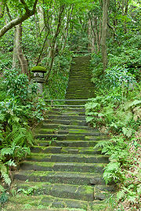

Myōhō-ji's mossy stairs
The site was originally occupied by a temple called Honkuku-ji (本国寺?), which was later transferred to Kyoto^{[7]}. Its first chief abbots were men from important families, and one of them was Nichiro, better known as Nichiei, the name he assumed when he became a priest, who was an uncle of Ashikaga Takauji and the temple's fifth chief abbot^{[4]}. Nichiei was a natural son of Prince Morinaga^{[8]}, and for this reason he rebuilt the temple in 1357 dedicating it to his father^{[9]}. Nichiei was born from a woman called Minami no Ōnkata, who attended the prince while he was a prisoner of the Ashikaga in the cave now at Kamakura-gū^{[4]}. He and his mother are buried within the temple, while Prince Morinaga's grave is in nearby Nikaidō^{[9]}. Nichiei installed two cenotaphs in memory of his parents on top of the hill behind the main hall^{[4]}. During the Edo period the temple was protected and maintained by the Tokugawa and their vassals^{[6]}. The temple is supposed to have been entrusted to Nichiei by Nichiren himself^{[4]}.

]Main features
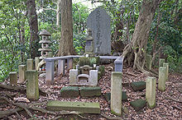

Cenotaph to Prince Morinaga
The main hall near the entrance contains, among other things, a small bone fragment said to be a relic of Nichiren and an effigy of Prince Morinaga^{[4]}. Like all other buildings of the complex, it is always closed to the public^{[6]}.
The building to the left of the main hall is called Daigakuden, and hosts statues of Shaka Nyorai, Katō Kiyomasa and Inari Myōjin, the kami of harvests^{[6][10]}.
The Niō gate behind them leads to the 50-step mossy stairway which today is the temple's main claim to fame, and which has gained it the above mentioned nickname "Kokedera". At the bottom of the stairs are two caves, of which one hosts a statue of Nichiren, while the other is a mausoleum to many of the priests that have lived here^{[4]}. Above the mossy stairs there is a third building called Hokkedō, or Hall of Scriptures^{[4]}.
Above the Hokkedō stands a monument, erected by the temple in the spot where allegedly Nichiren had his hut. As already mentioned, the exact point where the hut really stood has been the subject of much controversy for the past few centuries. Its plaque (in Japanese) reads:
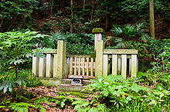
The monument on the spot where Nichiren's hut allegedly used to stand.
Nichiren's Matsubagayatsu's Hut
In 1253 Nichiren founded Nichiren Buddhism at Awa province's Seichō-ji (清澄寺?)^{[11]}and, in the summer of the same year, he came to Kamakura's Nagoe，made his hut, chanted the Daimoku, and wrote his Risshō Ankokuron. From here he spread his new religion until 1271.
Further on are the temple's bronze bell and the cenotaphs to Prince Morinaga and his wife^{[4]}. The plaque next to Prince Morinaga's cenotaph (in Japanese) reads:
Morinaga Shinnō, son of Emperor Go-Daigo Father of this temple’s fifth abbott Nichiei He fought actively for the establishment of the Kenmu restoration and was nominatedSeii Taishogun by his father, but was imprisoned in a cave in Kamakura’s Nikaidō. On August 12, 1335 (second year of the Kenmu era, 23rd day of the seventh month)^{[12]}, his tormented life was violently ended. He was 28. The tombs of Minami no Ōnkata, Nichiei’s wife, and of Nichiei’s himself are also within this temple.
http://www.asahi-net.or.jp/~qm9t-kndu/myohoji.htm
Historical Overview
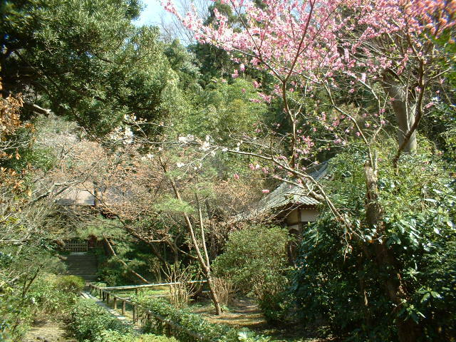
This is the place where Priest Nichiren, the founder of the Nichiren Sect, first settled in 1253 at the age of 31 to begin his missionary work in Kamakura, the nation's capital, coming from his home town in Chiba Prefecture.
Priest Nichiren is said to have lived here for more than 20 years making it as a propaganda base and was engaged in street preaching in Kamakura. As he fiercely attacked and criticized other religious sects saying they were heathenish, he often had to suffer persecutions.
Priest Nichiei (1334-1397), a devotee of the Nichiren sect and son of Prince Morinaga (1307-1335), to whom Kamakuragu Shrine was dedicated (for further details on Prince Morinaga, refer to Kamakuragu Shrine), built the Temple anew in 1357, and assumed the post of the fifth chief priest. From then on, the Temple was patronized by the Imperial Family in Kyoto. He also installed cenotaphs for his parents on top of the hill behind the main hall. Ryogon-zan Myoho-ji, the Temple's official title, was named after his childhood and Buddhist names.
In the Edo Period (1603-1868), the Temple was protected by the Tokugawa Shogunate and its affiliated feudal lords. The Eleventh Shogun Ienari Tokugawa (1773-1841) repaired to the Temple, and by his order, the entrance, Hokkedo, and Deva King gate were painted red.
The Temple has a number of precious statues and ancient writings. Unfortunately, most of them are not open to the public and doors of the halls enshrining Buddha statues are usually closed. In general, Nichiren sect Buddhists have a traditional principle of "Not giving, not receiving", or the policy that NichirenBuddhists should not receive or give offerings from or to other sects Buddhists. In other words, the Sect is a closed circle and stray worshipers rarely have a chance to get closer to and worship the statues. Even art books hardly run pictures of their statues.
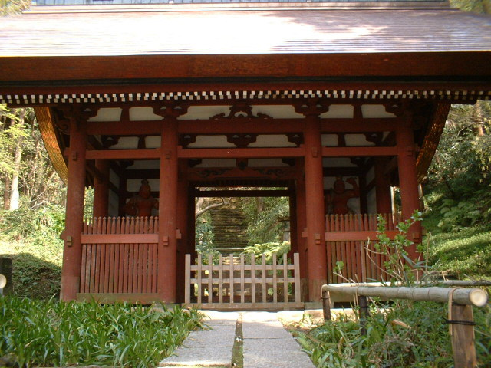

Main Hall:
As is often common in other Nichiren sect temples, the main objects of worship are sanbo honzon, consisting of a group of statues and the Odaimoku tablet, on which the words "Nam-myo-ho-ren-gek'kyo" are inscribed. Sanbo denotes three elements, and sanbo honzon in this case stands for the tablet, the statue of Priest Nichiren in the center attended by a statue of Shaka Nyorai (Sakyamuni in Sanskrit) to its left and Taho Nyorai (Prabhutaratna Tathagata in Skt.) to its right.
In addition, the following wooden statues are enshrined:
- Four-Bodhisattva relevant to Nichiren sect Buddhism.
- Monju: Manjusri in Skt., the Bodhisattva of Wisdom and Intellect
- Fudo Myo-o: Acala-vidyaraja in Skt., the Immovable.
- Aizen Myo-o: Ragaraja in Skt.
- Shiten-no: the Four Devas Kings
- A sedentary statue of Priest Nichiren, which has an inscription of 1826 make
The hall, made of zelkova trees, was built by the Hosokawa family, the lord of Kumamoto in Kumamoto Prefecture in the latter half of the Edo Period (1603-1868). The Hosokawa is a branch family of the Ashikagas, who established the Muromachi Shogunate in 1333 and had 16 generations of Shogun during the Muromachi Period (1333-1573). Morihiro Hosokawa (1938-), Prime Minister of Japan from August 1993 through April 1994, was the 18th generation of the Hosokawas.
Flowers are painted on the ceiling and sliding doors. Beams have ornamental engravings. The transoms are also beautifully decorated. The most talented painters and craftsmen available back at that time in Kumamoto were brought here to construct and decorate this hall.
Daigakuden hall
To the right-hand side of the main hall stands a small square structure, which is the Daigakuden hall. Wooden statues of Shaka Nyorai, Kiyomasa Kato (1562-1611), and Inari Myojin (the God of Harvests, popularly called Fox Deity) are enshrined. Kiyomasa Kato, a feudal lord in Kumamoto, built the Kumamoto Castle and was known as a devotee of Nichiren Buddhism, so devout that he was almost divinized. On the other hand, he was also known as the man who clamped down on Christians. The Kato's statue was presented to the Temple by the Hosokawa family. Inari Myojin is a Japanese deity of Shinto and has nothing to do with Buddhism. Enshrining both Buddha statues and Inari in the same hall exhibits a typical syncretism.
A picture (hanging scroll) of Kiyomasa Kato at MFA. He, dressed in armor on hoseback, holds a banner, on which seven kanji characters reading Nam-myo-ho-ren-gek'kyo are written.
Nio-mon, or Deva gate (Picture, right)
The path between the main hall and the Daigakuden hall leads to the Nio-mon, or a pair of two fierce-looking, giant guardian Deva Kings. The pair keep guard against demons and enemies of this sacred spot. They originate from the Hindu gods Brahm and Indra.
Moss-grown steps
The Temple is often dabbed as "the moss temple" with its moss-covered stone steps (roughly 50) leading up to the Hokkedo hall from the Deva gate. In order to preserve this natural beauty, visitors are not allowed to walk on the steps. Instead, there are spare flights parallel to it, from which visitors can observe the moss and walk up to the Hokkedo hall. From late April through May, white flowers of Shaga (fringed iris or Iris japonica) are in full bloom on both sides of the steps. In June, the moss is lively and most beautiful.
Hokkedo Hall
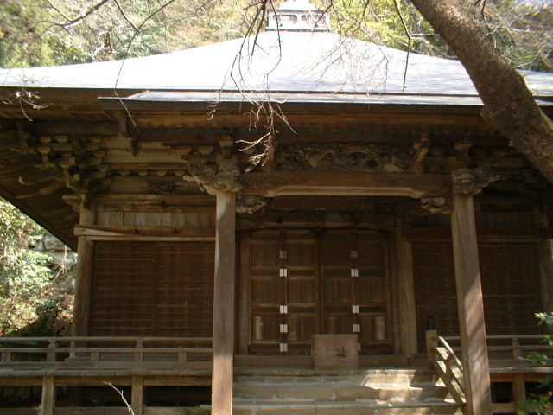
Hokke means Lotus Sutra and is commonly known as Nichiren sect Buddhism. The existing hall was built circa 1810 by the lord of Mito, a powerful feudal lord in Ibaraki Prefecture, which sent talented priests here, including the 32nd chief priest Nichio and the 33rd chief priest Nichiji. The square building with beautifully sloped roofs is called Hogyo Zukuri in Japanese. Inside the building is a magnificent feretory in which a sedentary statue of Priest Nichiren, the main object of worship at this hall, is enthroned.
The feretory and statue are unveiled only twice a year; on August 27, September 12 and 13. Shortly before Priest Nichiren was persecuted on the evening of August 27, 1260 by the mobs of other sects, says the legend, a white monkey had appeared out of nowhere and he pulled the Priest by the sleeve to get out. By his help, Priest Nichiren was able to get off the danger and sought refuge in the south side of the hills called Nagoe. This monkey is said to have brought ginger to Priest Nichiren in refuge, with which the Priest was able to survive. Ever since, the Temple has been holding memorial services on August 27 and September 12 and 13 (another persecution day) with ginger presenting to worshipers. In the Temple, ginger is thought to be an amulet against evils and served to all participants on these specific occasions.
In front of the Hokkedo hall, there stands a big Japanese sago palm tree, or a cycad, which is said 650 years old and was planted by Priest Nichiren himself.
Ruins of Priest Nichiren's hermitage
Ahead of the sago palm tree and near the bell is another flight of stone steps which bring you up to the ruins of Priest Nichiren's hermitage. This is the site where Priest Nichiren lived for 20 years and commuted to busy corners of the streets in Kamakura for street preaching. There are three Nichiren-Sect temples in this vicinity each claiming that Priest Nichiren first settled in its temple. The other two are Ankokuronji and Choshoji. God knows exactly where he settled.
Cenotaphs for Prince Morinaga and his wife
The narrow path in front of the ruins stretches to the north and south. A further walk to the south, there is the Prince Morinaga's Gorinto or cenotaph on a ridge. His real tomb is placed near Kamakuragu Shrine supervised by the Imperial Household Agency as he was a member of the imperial family.
Going up north, there are several stone towers including that of Lady Minami, mother of Priest Nichiei and wife of Prince Morinaga. Lady Minami is also enshrined at a sub-shrine of Kamakuragu Shrine.
Myoho, the name of the Temple, came from Saddharma of Sanskrit meaning the right doctrine. It is a part of seven invocation letters of Nam-myo-hoh-ren-gek'kyo, the words for adoration to the Lotus Sutra always chanted by Nichiren-sect Buddhists.
Annual observances
- April 15: Myoho Inari Festival
- May 5: Festival for Kiyomasa Kato
- July 23: Memorial service for Prince Morinaga
- August 27: Memorial service for the Matsuba-ga-yatsu persecution. Matsuba-ga-yatsu is the name of this part of Kamakura.
- September 12: Memorial service for the Tatsunokuchi persecution. For details, see Ryukoji.
Note: At the ticket booth, visitors are required to read and follow the Temple's instructions written on a bulletin board. In short, visitors have to behave themselves appropriate to the sacred spot. No tripods are allowed in the Temple's grounds. In a recent visit to the Temple, I found a signpost at the main hall reading "Do not clap hands." There seems to be some visitors who do not tell Buddhism from Shinto.
Be careful that the Temple is different from Myohonji (with an n in the alphabets).

