Minobu-San Kuonji Temple
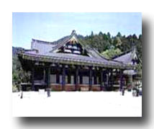
Minobusan Kuonji Temple was established by Nichiren Shonin (1222 - 1282), the founder of the Nichiren sect of Buddhism. As the Nichiren Shu's Grand Head Temple, as well as the site of Nichiren Shonin's tomb, Kuonji is the most sacred place of worship for the sect's followers.
Mt. Minobu is located in what was then known as HakiinoGo, in the old province of Kai (now Yamanashi Prefecture).
The magistrate of this area, Nambu Sanenaga, was a follower and patron of Nichiren Shonin and invited him to stay there after he left Kamakura. Nichiren Shonin arrived at Mt.
Minobu on May 17, 1274 and, one month later, he settled in a hermitage built with Nambu's help.
Sanmon (Temple Gate)
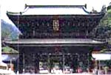
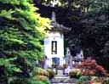
Sobyo (Nichiren Shonin's Mausoleum)

Nichiren Shonin continued his recitation of the Lotus Sutra and instruction of his disciples at the new hermitage. On November 24, 1281, however, he left these quarters to build the full-scale temple nearby, which he named Minobusan Kuonji.
It would be where he would live and teach until his death. In the autumn of 1282, he set out for a hot spring in the province of Hitachi in order to restore his failing health and to pay homage on the way at his parents grave. He never returned.
He died at Ikegami in the province of Musashi (in the Ota Ward of today's Tokyo) at the age of 61. In accordance with his will, his ashes were brought back to Kuonji and enshrined in a mausoleum there.

