Kaikozan Butsugen-ji Temple
Address:
2-30 Monomigaoka Ito-shi Shizuoka-ken
Direction:
JR Ito-sen Ito-eki -> Bus for Shimota/Atsukawa ->
Ohara-machi stop -> 5 minutes on foot
JR Ito-sen Ito-eki -> Bus Arai-sen Butsugen-ji stop ->
10 minutes on foot (There are stone steps to climb.)

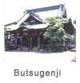

Butsugen-ji is closely related to Izu Persecution. This is the place where Nichiren Shonin was exiled, and this temple is also known as the place where his Zuishin-butsu rests. Nearby beach there is the famous Manaita-iwa (Chopping board rock), where Nichiren Shonin was deserted to die by raising ocean water, and the couple, who rescued Nichiren Shonin, Funamori Yasaburo and his wife rest at Renkei-ji Temple in the same region.
Spring of 1261, Nichiren Shonin returned to Kamakura from Shimousa, but he was captured and sent away to Izu. He convinced his disciple Nichiro not to accompany him and went on a boat to be taken away on May 21.
The boat arrived at a bank called Kawana in Ito. Yasaburo and his wife took Nichiren Shonin in secretly and served on him. Eventually Nichiren Shonin was sent to the local tax official, Sukemitsu Ito to be kept under the watchful eye. However Sukemitsu turned to Nichiren-shu when his illness was cured by Nichiren Shonin's prayer. He also present the statue of the Buddha discovered in ocean. Nichiren Shonin treasured and worshiped this statue as his Zuishin-butsu.
The beginning (Engi): Sukemitsu Ito had Bishamon-do built for Nichiren Shonin to protect him from the evil. Nichiren Shonin had lived in Bishamon-do while he was exiled in Ito. Butusgen-ji was built where Bishamon-do once stood.
Nichiren Shonin wrote "Shion-sho" and "Kyoki Jikoku-sho" at this site.
The current condition: Sanmon (the main gate) was built in late Tokugawa-era (mid 19th century.) Soshi-do (the founder's hall) and new Bishamon-do were built in 1951 to commemorate the 750 Anniversary of Nichiren Shonin's birth.
Story about Nichiren Shonin's Zuishin-butsu
June of 1261, when Nichiren Shonin was exiled to Ito, something on the bed of ocean nearby was shining day or night. People were afraid of it as the precursor of some incident. People threw the net into the ocean to catch the object, and the golden colored standing statue of the Buddha was brought up to the shore. Jito (the local tax officer) Sukemitsu Ito happened to be suffering from unknown illness and he asked Nichiren Shonin's prayer. Then he got instantaneously cured, and this caused him to become a follower of Nichiren Shonin. He also presented this golden Buddha from the ocean bed. Nichiren Shonin cherished this Buddha and carried it with him for the rest of his life.
The most devoted practitioner of the Lotus Sutra in Japan
Nichiren Shonin had realized the relationship between the Lotus Sutra and himself while he was exiled in Izu. Accordingly through Izu Persecution Nichiren Shonin experienced himself what the Lotus Sutra stated. He had reached to the conclusion that the merit of the Lotus Sutra would lead one to repay the four essential favors: every sentient being, the ruler, one's parents and Three Treasures (Buddha, Dharma, and Sangha) - "Shion-sho." He also realized that he himself was the one to recognize the enemies of Hoke-kyo in Japan - "Kyoki Jikoku-sho" .

静岡 仏現寺 Shizuoka Butsugen-ji Shizuoka Butsugenji Temple

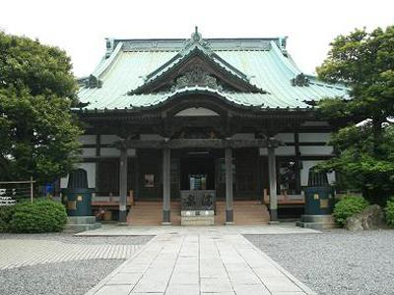
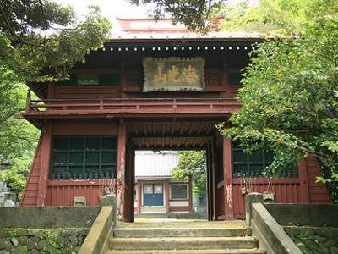

Butsugenji Temple located in Monomigaoka, Ito City, Shizuoka Pref. is one of Nichiren-shu Reiseki Honzan (the temples where Nichiren himself conducted an important deed). The temple was given its name by Nichiren, who was exiled to Izu in 1261 and spent three years at this temple. The principal image is Kuon no Honshi Shakamunibutsu (Eternal Buddha, Shakamuni). The temple is formally named Kaiko-zan (literally meaning “Sea Light Mountain”) Genbutsuji (Emergence of Buddha) Temple, which comes from the episode that Ito Hachirozaemon, the Jito (the local manor manager) of this area presented Nichiren with the standing statue of Buddha, which he had brought up from the sea. Butsugenji Temple is counted as one of Ito Shichifukujin (the Seven Deities in Ito), where Bishamonten (the god of war and warriors), who brings good luck, purification of the evil, and luck with money, is worshipped. The temple also owns a mysterious scroll called “Tengu no Wabi-shomon (the apologetic letter from a Tengu),” which has been indecipherable until now. This is a historic temple with a lot of legendary stories.

