Ankokuron ji
Ankokuronji is one of several temples of the Nichiren sect of Japanese Buddhism along the hills in the southeast of Kamakura. Nichiren himself founded Ankokuronji around 1253 when he first came to Kamakura, and he is said to have lived at the temple for several years.
Visitors can walk along a short hiking trail through the wooded hills around the temple buildings. A nice view of the city of Kamakura can be enjoyed underway. Some of the trail's passages are quite steep and should only be explored with good walking shoes and during dry weather.
HistoricalOverview
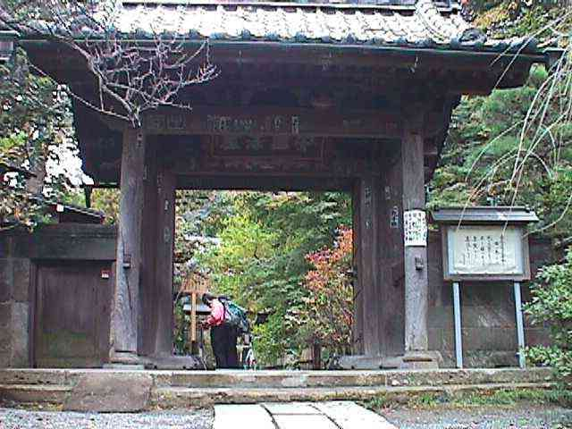

Priest Nichiren, the founder of Nichiren sect Buddhism, was born in a fishing village in Chiba Prefecture, and came to Kamakura in 1253 at the age of 31 to start missionary work. The Temple claims that Priest Nichiren made a hermitage right on this site, and engaged in various propagation activities over 20 years. Neighboring temples Myohoji and Choshoji also claim respectively that his real hermitage was in their temple precincts. The district is called "Matsuba-ga-yatsu", and it covers Myohoji district as well.
In the mid-13th century, Zen sect Buddhism was booming in Kamakura backed by Tokiyori Hojo (1227-1263), who was then in power as the Fifth Hojo Regent and constructed Kenchoji.
Priest Nichiren wrote a famous treatise entitled Pacifying the State by Establishing Orthodoxy in 1260 when he was 39 years old, and presented it to the Regent Tokiyori Hojo. Back at the time, a series of natural disasters and social unrest occurred making people uneasy and scared. In the treatise he addressed that the government should choose the right religion, namely, the Lotus Sutra, and establish the essential truth of Buddhism. Reforming the society through his dogma is the only way, he insisted, to keep the country secure. The title of this treatise is called Rissho Ankokuron in Japanese, and the namesake of Ankokuron-ji.
However, the Regent and the Kamakura Shogunate did not show any interest in, much less employ his doctrines. Priest Nichiren started his preaching to the people in Kamakura at busy street corners, bitterly criticizing other sects, which in turn provoked their antipathy toward him, and eventually provoked attacks by mob-like Buddhists of the criticized sects. Included among them were Jodo sect Buddhists patronized by Shigetoki Hojo (1198-1261), who was a family member of the Hojos and contributed to the construction of Gokurakuji. Faced with the assault by those anti-Nichiren Buddhists in 1260, the Priest was forced to flee from Kamakura. Returning shortly afterward, he continued his campaign undergoing similar persecutions, but he was not fazed at all.
As to exactly where Priest Nichiren settled in Kamakura, it has long been an issue disputed by the three temples mentioned above with their close proximity. They even filed suits against the others and argued in the law court. An academic survey concluded, however, that present-day Ankokuronji was the exact place where Nichiren first settled, and after the first persecution by the mobs, he made another retreat at Myohoji adjacent to Ankokuronji. On the other hand, Choshoji, 200 meters away from Ankokuronji, had nothing to do with his retreat, so revealed the survey.
Main Hall
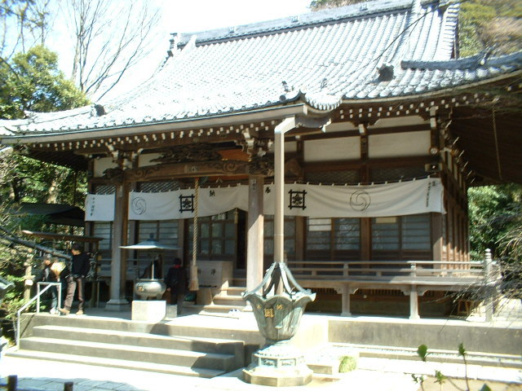
The current building is rather new, constructed shortly after the Temple was destroyed by the fire in 1961. The main object of worship, the sedentary statue of Nichiren, is fairly new chiseled in 1963. Also placed on the altar are theOdaimoku Tablet, and statues of the following Buddhist deities and priests:
- Kishimojin, or the Goddess of Children (Hariti in Sanskrit)
- Jura-setsu-nyo (raksasa in Skt.): Ten devil-women that appear in the Lotus Sutra. After learning Buddhism, they turned devout believers in the Lotus Sutra and swore to help those who believe in it. Kishimojin andJura-setsu-nyo are often venerated by Nichiren sect Buddhists. A hanging scroll of Juna-setsu-nyo at NNM.
- Daikokuten: The God of Wealth or the God of Five Cereals (Mahakala in Skt.) A statue of Daikokuten at NNM.
- Priest Nichiro (1243-1320): One of the Nichiren's six immediate disciples and the second chief priest of the Temple.
- Shichimen Daimyojin: The guardian deity of Kuonji, the headquarters of all Nichiren sect temples situated in Yamanashi Prefecture.
Go-shoan or Small Hermitage
A sedentary statue of Priest Nichiren's is enshrined in this structure. The wooden statue is Nichiren himself with a posture writing the famous treatise. It was carved circa 1700. The Gosho-an (go is an honorific) structure, made of zelkova trees, was rebuilt in the late 17th century under the sponsorship of the Tokugawa family of Nagoya, one of the three largest branch families of the Tokugawa Shogunate in the Edo Period (1603-1868).
In front of the structure is an old cherry tree, of which seedling, according to legend, was brought here from Chiba Prefecture by Priest Nichiren. Together with nearby kaido (aronia or Malus halliana) and sazanka (sasanqua or Camellia sasanqua), the old cherry is a Precious Natural Product designated by the city of Kamakura. In early to mid April, an open-air tea ceremony is held every year under a dense canopy of pink kaido blossom.
Cremation site for Priest Nichiro
Priest Nichiro passed away in 1320 at the age of 78. At the deathbed, he left a will requesting that he be cremated right here where he took the tonsure to become a disciple of Nichiren. In accordance with the will, he was cremated here and his remains were buried in this structure.
He joined the Nichiren school in 1254 at age 10, and devoted his entire life to studying Nichiren Buddhism. It is said that wherever Priest Nichiren went, always with him was Priest Nichiro. Not only was he the second chief priest of the Temple, he was also a founding priest of Myohonji and Kosokuji in Hase. The present structure was rebuilt in 1982 and a Gorinto stone stupa as well as his mortuary tablet are installed inside.
Kuma-o-den (Hall)
Kuma-o is the name of a samurai in the mid-14th century. He joined a samurai band led by another samurai called Masanori Kusunoki who had killed Kuma-o's father. Kuma-o joined Kusunoki's retainers with a false identification and looked for an opportunity to kill him for vengeance. Contrary to his expectations, Kusunoki turned out to be a trustworthy samurai and so good to Kuma-o that Kuma-o was overcome by his affection and unable to revenge. Instead, he took Buddhist vows and served Priest Nichiren.
Meanwhile, Masanori Kusunoki was the third son of Masashige (1294-1336), a great hero in the Japanese history as a loyal warlord in Osaka. But, Masanori's birth and death years are unknown.
Fujimidai (Mt. Fuji-viewing spot)
A flight of steep steps near the Kuma-o-den leads up to a spot on a hill, from where visitors can have a fine prospect toward west and command a fine view of Mt. Fuji should the weather be good enough. Unfortunately, nowadays view will reveal only those ugly roofs of private houses spread below, and Mt. Fuji can rarely be seen. Priest Nichiren used to come up here every morning and recite sutras facing Mt. Fuji. In summer, this part is overgrown with bushes and visitors need to be careful so as not to be stung by bees and mosquitos.
Nanmen-kutsu (South-facing cave)
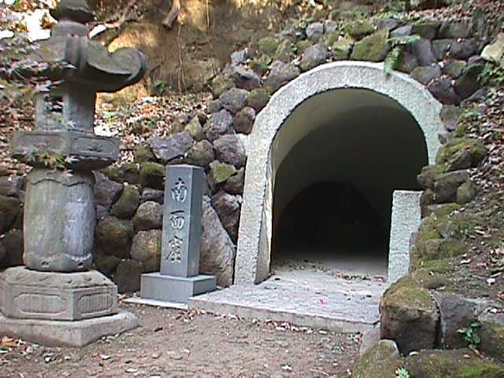
Further up the viewing spot, there is a cave. Priest Nichiren was attacked in 1260 by thousands of Jodo sect mobs after he presented his treatise to Tokiyori. He was forced to run away and in the end took a temporary shelter here in this hideout. According to the Temple's legend, a white monkey appeared near Priest Nichiren before his evacuation and the monkey led him to this cave, form where he was again led out to the other side of the mountain. But for the monkey's help, he might have been caught by the mobs and killed. To commemorate the monkey who saved Priest Nichiren's life, a statue of the white monkey is housed in here. Placed in the left recess of the cave is a sedentary statue of Priest Nichiren himself.
Annual observances
First or second Sunday of August: Segaki (hungry-ghosts-feeding rites) or mass for the departed souls.
September 27: Memorial service for Priest Nichiren in commemoration of his persecution in 1260.
Notes:
In the Temple's cemetery, ashes of Toshio Doko (1896-1988), a famous industrialist and a role model for Japanese businessmen, are buried together with his wife's. He was chairman and CEO of a leading heavy industry company named IHI (which stands for Ishikawajima-Harima Heavy Industries), and served as chairman of the Japan Economic Federation as well as the government's Administration Reform Council in the 1980s. There is an episode on his spiritual cleanliness. Once his company was suspected of giving bribery to government officials when he was president. One day, public prosecutors visited his home to interrogate him early in the morning. However, he had already left for his office by train as usual, not by a chauffeured car as was usually the case with typical Japanese CEOs. Learning this, the prosecutors gave up questioning him. They thought CEOs who commute early in the morning using public transportation would never be involved in the bribery scandal or other wrongdoing. He used to live in a humble, cottage-like house, and when he died, his wife donated all his fortune to a school he had been supporting without leaving any assets to their children, and she died just one day after the 7th anniversary of her husband's death on August 5, 1995 at the age of 92.
According to the author of his biography, he used to get up at 4 o'clock every morning and chant sutra for half an hour. He left house at 6:30 a.m. and in the office by 7:00. He was an all-out rationalist. All conferences in the company had to be finished within two hours. As a result, members of the Board had to keep standing while they were in conference.
Later in 2008, however, the company was sued by shareholders on the charge of accounts fraud, and the company's stock was on the brink of delisting from the Tokyo Stock Exchange. Were Mr. Doko alive today, account-rigging is the last thing he would have done. Meanwhile, when I dropped in the Temple in late October 2008, the Dokos' grave was one of the few in the graveyard that were kept clean with beautiful flowers.

