Shochuzan Hokekyo-ji Temple

Address:
2-10-1 Nakayama Ichikawa-shi, Chiba-ken
Direction:
JR Sobu-sen Shimousa Nakayama-station -> 15 minutes on foot
Keisei Nakayama-station -> 5 minutes on foot
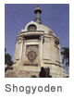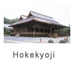
The street leads to the temple starts at Sobu-sen Shimousa Nakayama-station and had created a town alongside over the years. The compound is consist of many buildings such as Daido (Great Hall), Shodo, Shoto, and it is always filled with the followers paying their respect. In other words, this is the temple well-supported by both priests and congregations.
Nichiren Shonin avoided the Matsubagayatsu Persecution by running away to Shimousa and he relied upon Jonin Toki, the head of Gozoku (prominent family) in Wakamiya as well as a devoted follower. In August of 1260, the Hokke-do (later it became Hokke-ji) was built within Toki's residence. Nichiren Shonin had offered his 100-day sit-in lecture there between the end of the year and spring. Accordingly this temple is regarded as the sacred site of Honge Shoten Borin (Nichiren Shonin's first preaching the Dharma). Soon another Gozoku in near by area of Nakayama, Jomyo Ohta built Jibutsu-do (later became Honmyo-ji) on his property. Jibutsu-do was blessed by Nichiren Shonin when its construction was completed.
The beginning (Engi): Hokekyou-ji was founded in August of 1260. Jonin Toki became a priest after Nichiren Shonin passed away in 1282 and changed his name to Nichijo. The following year he entered Honmyo-ji when Jomyo deceased. In 1297, Nichijo made a rule to keep all documents left by Nichiren Shonin at the temple in order to protect them from getting lost. All the documents have been kept safely at Shogyo-den until this day. When Nichijo passed away, the son of Jomyo, Nichiko became the second priest of Hokke-ji and established Honmyo-ji as well. Thus from this point on, the main priest oversee both temples together. This system is called, Ryozan Isshusei (one head priest for the two temples). After Nichiko passed away, Nichiyu became the third priest of Hokke-ji and Honmyo-ji and he invited another Gozoku, Tanesada Chiba to head the congregation. Tanesada generously contributed a large land to the temple to secure the temple's financial situation. Nichiyu vigorously spread the mission, chanting of the Lotus Sutra, copying the Sutra as well as built a Shoja (a dwelling place for diligent practitioners.) He also made many pilgrimages to Mt. Minobu. These visits resulted that his disciple, Nikka (originally from Gozoku family in Musashinokuni Mutsuura) to make finanical contributions to Mt. Minobu. He also gathered the documents written by Nichiren Shonin and created the index of them. He established some systems within the organization such as Shiinkasei and Doshishokusei.
This line of Nakayama-monryu (the linage of Nakayama) has contributed to the Nichiren-shu from Nanboku-cho era to Muromachi-era by sending extraordinary priests: Haniya Myosen Nichiei, Kenpon Hokke-shu Nichiju, Honpo-ji Nabekamuri Nisshin, Chomyo-ji Nisshuku. Hokke-ji and Honmyo-ji were united during Sengoku-era and formed Hokekyo-ji. The eleventh priest of Nichiden was exiled to Hagi (current Yamaguchi) by Toyotomi Hideyoshi, and this caused to form Sanzan Rinban Sei (the system to take turn of taking care by the three temples) among Kyoto Komyo-ji, Honpo-ji, and Sakai Myokoku-ji. During early Meiji-era in 19th centuary, the Buddhism in Japan was prosecuted as a result of Haibutsu Kishaku (the anti-Buddhist movement that led to the destruction of Buddhist temples and images). After the World War II Hokekyo-ji establised Nakayama Myoshu and rejoined Nichiren-shu in 1973.
The temple is also well-known all over Japan as Kito Reijo (a sacred site of Kito blessing) for three Hiho (esoteric methods of practice.) First people visit here to pray at Kishimo-jin (the Buddhist goddess, who is beautiful and blessed with many children, to help people with childbirths and child care.) It is said that Nichiren Shonin came over this place to avoid Komatsubara Persecution; carved the statue of Kishimo-jin, and taught Toki Jonin about hidden teaching of this goddess. In Edo era, this statue was called Nakayama Kishimo-jin and worshiped by many people who wished to have Genze Riyaku (benefits in this life such as good health, child rearing and so on.)
Second this temple is the place for Aragyo ( 100days ascetic practice.) In order to become a Shuhosshi (certified priest to perform Kito blessing) of Nichiren-shu, one must complete one-hundred-day training starting on November 1 at Nichiren-shu Kegyosho to receive hidden teaching. This training includes a famously difficult session called Kanchu Suigyo, practice of cold water purification in winter.
Finally there is a hidden teaching of Bokken Kaji (Kito blessing with wooden sward). This method of Kito blessing is allowed to be practiced by only Shuhosshi completed the Aragyo training. The prayer summons up the Kishimo-jin; apply the juzu to a bokken (wooden sword); chant the prayer; pray to rid of all evil. Consequently this prayer brings people to rest their minds and pray for the Rissho Ankoku, establishing peaceful country with right teaching.
The current condition: The temple holds various historically significant structures. Soshi-do (founder's hall), designated as Juyo Bunka-zai (a national cultural treasure) was rebuilt in Enpo-era (1673-81). Other national cultural treasures are Hokke-do, built in Muromachi-era and Shisoku-mon. Hokke-do is the oldest structure and believed to be the main structure of Honmyo-ji. Goju-no-to(the five story pagota,) built in 1622, is also the national treasure. There is a substantial addition, Shogyo-den built in 1931. Others worth being mentioned are: Kishimojin-do, Aragyo-do, and Joshuden (the guest house.)
The temple maintains numerous sacred treasures as well: Kokuho(national treasure) "Rissho Ankoku Ron," Kokuho "Kanjin Honzon-sho," and national cultural treasure, Nichiren Shonin's document in 56 volumes and others. These are shown to public only once a year on November 3. Countless numbers of historical documents, the statue of Nichiren Shonin, all other priests' statues, statues of the Buddha, pictures all date back to the Middle Ages.
The temple holds many annual events: Senbu-e (April 15-20,) opening of Shogyo-den (November 3,) Oeshiki (November 15-18,) Nyugyo-e (the beginning of the Aragyo training. November 1,) and Shutugyo-e (the end of Aragyo. February 10.) The eighth day of every month is the Kishimo-jin day (especially the special prayer is held on the eighth of January, May and September) and many people gather at the temple.

Nakayama Hokekyo-ji is the prime temple called, "Dai hon yama" for the Nichiren Buddhist sect. (Dai hon yama refers to the temple with the highest position in every Buddhist sect). In the Hokekyo-ji temple, the writings and mementos of the Nichiren Buddhist saints are well preserved. These items have been designated as national treasures and important cultural assets that are being kept inside the Shogyouden (storage facility of the temple).
Moreover, in its vicinity, there are many other designated important cultural assets, like buildings, paintings, etc. In fact, almost 1/4 of the city's designated cultural assets can be found in Hokekyo-ji. Due to the presence of many temples with tall towers or pagoda within its surroundings, ever since the Edo Period, the road from Chiba Main Road (now, National Route 14) that lead to the Hokekyo-ji, was developed into a Temple town entrance, which made it more interesting for temple visitors coming from different places. Around the Nakayama district, many traditions related to the faith of Nichiren sect still remains.
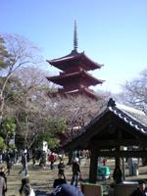

い
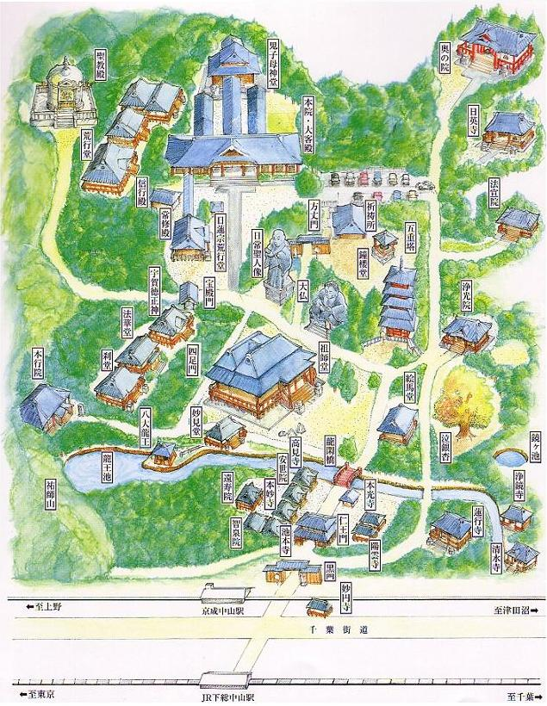
http://www.hokekyoji.com/image281.jpg境内図（プリント用）

