APPENDIX

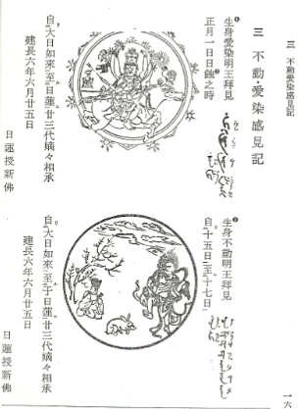
Figure 1. Copies of the paintings of Rangaraja (Japanese. Aizen) (top) and Acala (Japanese. Fudo-Myoo) (bottom), the two Kings of Knowledge drawn by Nichiren in 1254. This picture was taken from Nichiren’s Fudo Myoo Aizen Kankenki from the Showa Teihon Ibun.

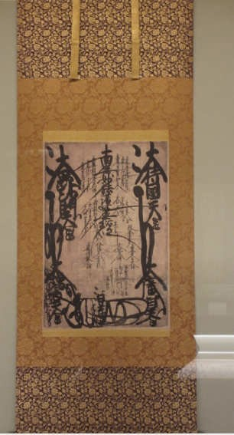
Figure 2. Picture of Nichiren’s Mandala at the Kuonji Temple at Mount. Minobu. The picture was taken at the museum at the temple during my trip to Japan.

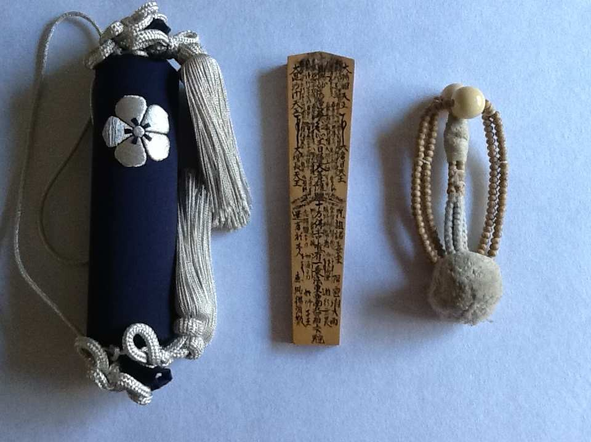

Figure 3. Picture of senkyo (left), bokken (middle), and juzu used for kaji kito (right).

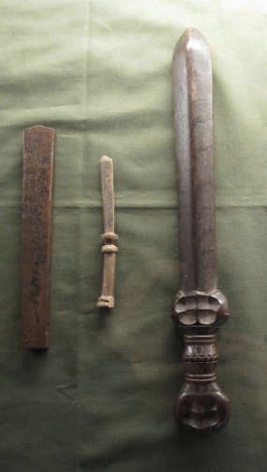
Figure 4. Picture of different types of bokken used throughout the history of the kaji kito in Nichiren Shu Buddhism. The bokken on the very right is thought to be the oldest, while the bokken on the left is thought to look the most similar to the bokken used today. These objects can be found at the museum at the Kuonji Temple in Mount. Minobu. This picture was taken during my trip to Japan.

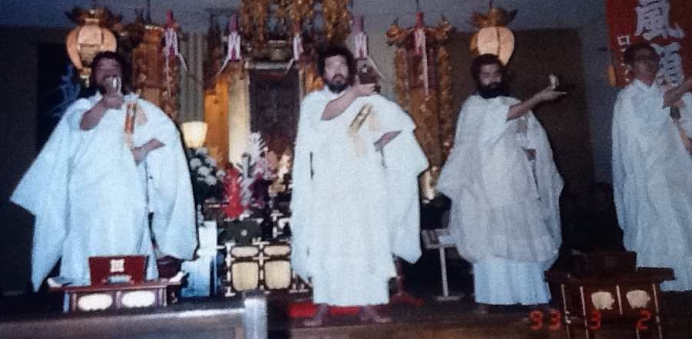
Figure 5. The pictures of priests lined up doing kuji using both the bokken and juzu. My father is the second individual from the left.

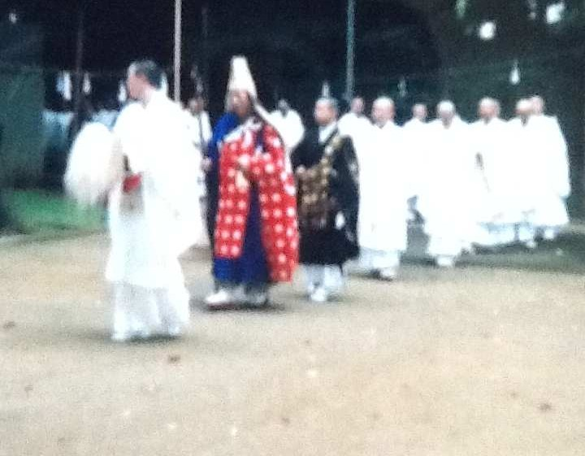
Figure 6. The priests are lined up moments before entering the zuimon to start their aragyo training. This picture along with Figures 7 and 8 are pictures from the times when my own father entered aragyo practice.

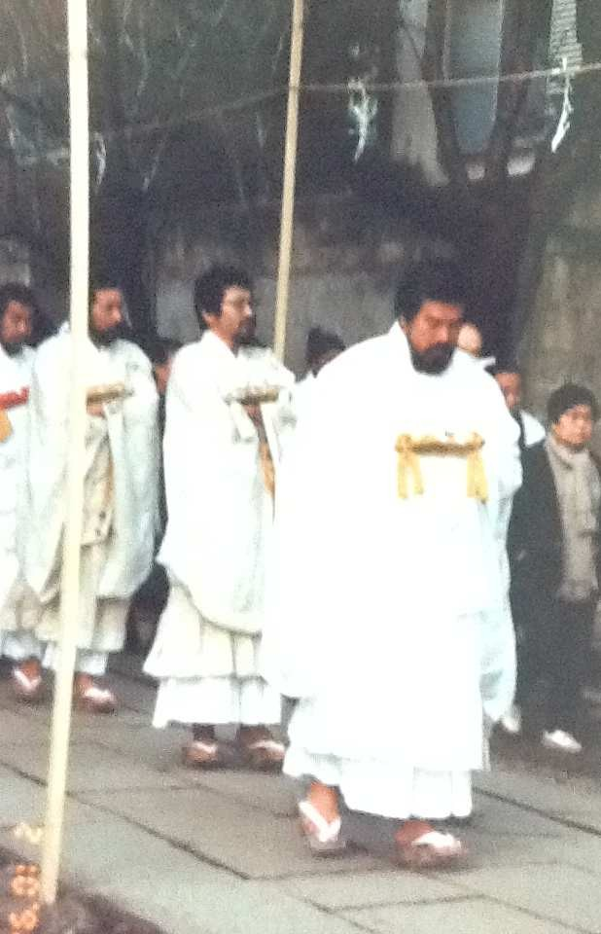
Figure 7. The priests lining up moments after leaving the zuimon after completing their 100-day practice. My father is the first gyoso shown from the right.

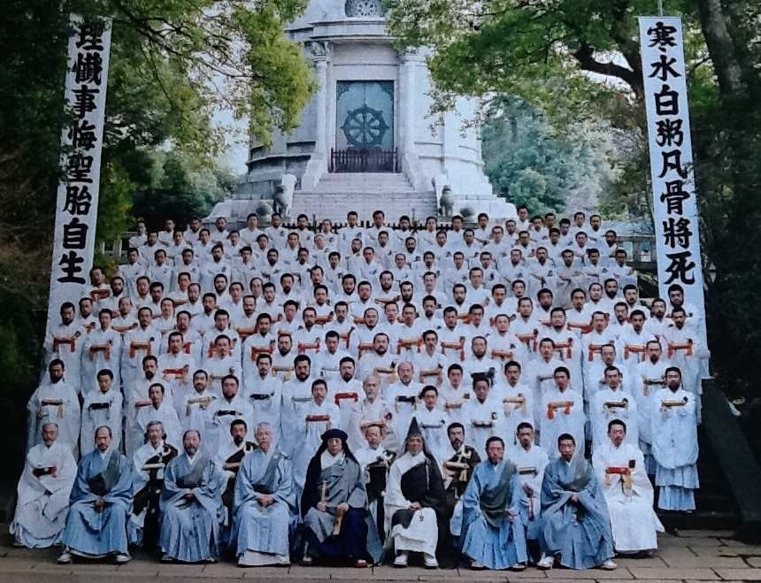
Figure 8. The picture of priests lined up after completing their aragyo training. The two flags shown read “kansui byakujiku bonkotsu masani karenantosu” (right) and “rizanjige shotai onozukara shozu” (left) and encompass the essence of the aragyo training.

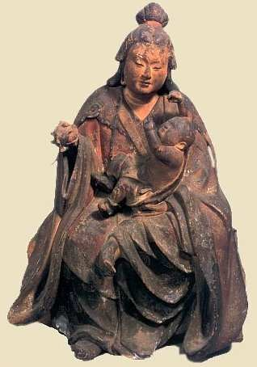
Figure 9. A sculpture of Hariti (Japanese. Kishimojin) from the Kamakura period at the Onjoji Temple in the Shiga Prefecture. She is holding a pomegranate in the right hand and Priyankara with her left. The photo is courtesy of The Hidden Buddha of Japan (2002), Corona Books.
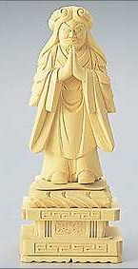
Figure 10. A modern-day sculpture of the “demon-faced” Hariti. The photo is courtesy of a Japanese store selling sculptures and necessary objects for Buddhist altars (www.butsudanya.co.jp).

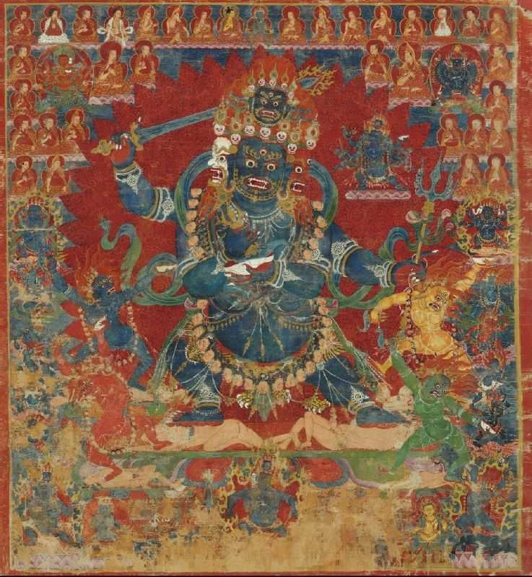
Figure 11. A painting of Mahakala (Japanese. Daikokuten) from Tibet (15th Century). This is suggested to be one of the earlier known paintings of Mahakala. The picture of this painting is courtesy of the Himalayan Art Resources website.
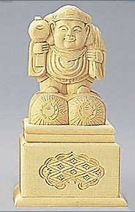
Figure 12. A modern-day carving of the smiling Mahakala. The photo is courtesy of a Japanese store selling sculptures and necessary objects for Buddhist altars (www.butsudanya.co.jp).

